# MEHTODOLGY AND ALGORITHM :

Basic idea behind this method is to imagine the 3 dimensional prismatic object as a binary matrix as shown in the given diagram. To get more accuracy in shape, value of n can be increased.

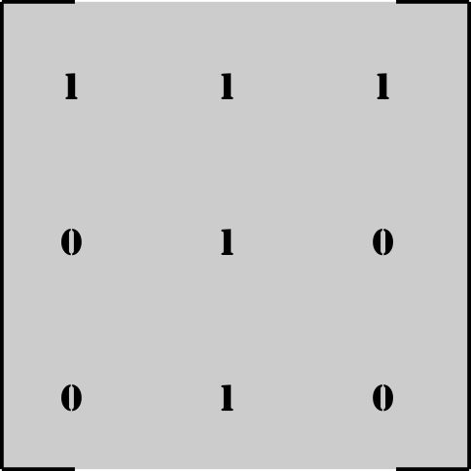



Prismatic object having T-shaped base In this case, n = 3.

So now, we have to solve for these n2 variables whose values will either be 1 or 0. For these we plan to get n2 linearly independent linear equations. Then we will use matrix inversion method to solve for n2 variables.

# MEHTOD FOR OBTAINING A LINEAR EQUATION BY IMMERSING OBJECT IN WATER :

Let’s consider an object shown and imagine it as a binary matrix. For simplicity of understanding, let’s take n = 3 (i.e. 3x3 matrix).

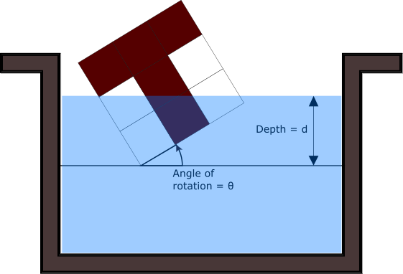 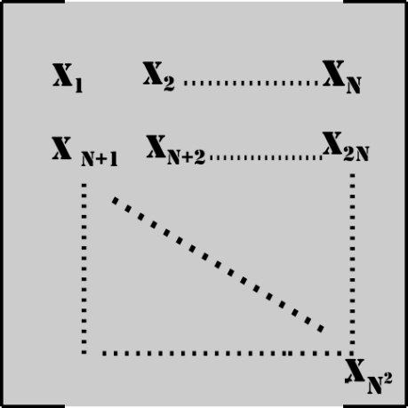

Now, rotate the matrix by an angle ‘ϴ’ clockwise and dip it in the water by a depth ‘d’. As shown in figure below, contribution by each cell in amount of water displaced will be equal to

‘(Ci ). (Xi)’.

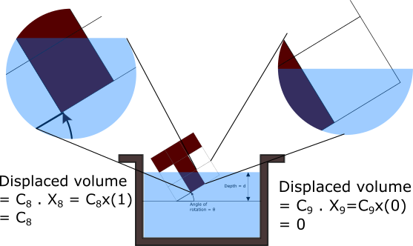

So total volume displaced will be

Vdisplaced =

Where,

Ci is the ratio volume submerged in water to total volume of ith cell

Xi = 1 if ith cell is filled,

0 if ith cell is empty.

For each value of ‘ϴ’ and ‘d’ we get an equation.

Now, problem arises that many of these equations we get for different values of ‘ϴ’ and ‘d’ are linearly dependent. We need exact n2 linearly independent equations. This will make sure that we get a unique solution.

# Method to get n2 linearly independent linear equations :

1. Take a square matrix A n2 x n2. Make all the elements of the matrix 0. Take different values of ‘ϴ’ and ‘d’. For each value of ‘ϴ’ and ‘d’, we will get a equation of form $\sum_{1}^{n^2}{(Ci ). (Xi)}$.
2. Replace a row of matrix A having all elements 0 by C1, C2, C3 … C(n^2) respectively. Check whether rank of matrix A has increased after replacing the row.
3. If the rank has not increased, then make all the elements of that row 0 again.
4. If the rank has increased, then replace that row permanently with C1, C2, C3 … C(n^2) respectively and note down the values of ‘ϴ’ and ‘d’.
5. Continue the same procedure for new values of ‘ϴ’ and ‘d’ until we get the rank of A equal to n2. Now this matrix A will be the coefficient matrix which we can use in matrix inversion method.

Basically, if the rank of A increases after replacing a row, it means that the equation we have, is linearly independent with all other equations which previously have replaced a row in matrix A.

So, this is how we can obtain coefficient matrix whose rank is n2.

# VOLUME MATRIX :

VOLUME MATRIX :

For matrix equation of form:

[Coefficient matrix] x [X] = [Volume matrix],

We have obtained coefficient matrix of size n2 X n2 whose rank is n2. Now we only need to find volume matrix. For getting volume matrix, we use the n2 values of ‘ϴ’ and ‘d’ which we had noted down while finding coefficient matrix. Using those values, we transform the object accordingly and dip it. We can then measure the volume of water displaced, and get the Volume matrix.

So, now that we have found both, coefficient matrix as well as volume matrix, using simple matrix inversion method, we can get the values of all the variables.

[X] = [Coefficient matrix]-1 x [Volume matrix]

The following algorithm takes ‘n’ as input and outputs the coefficient matrix and corresponding values of ‘ϴ’ and ‘d’.

A code was implemented which took ‘n’ as input and gave the coefficient matrix and corresponding n2 values of theta and d. This code is based on following logic.

# ALGORITHM :

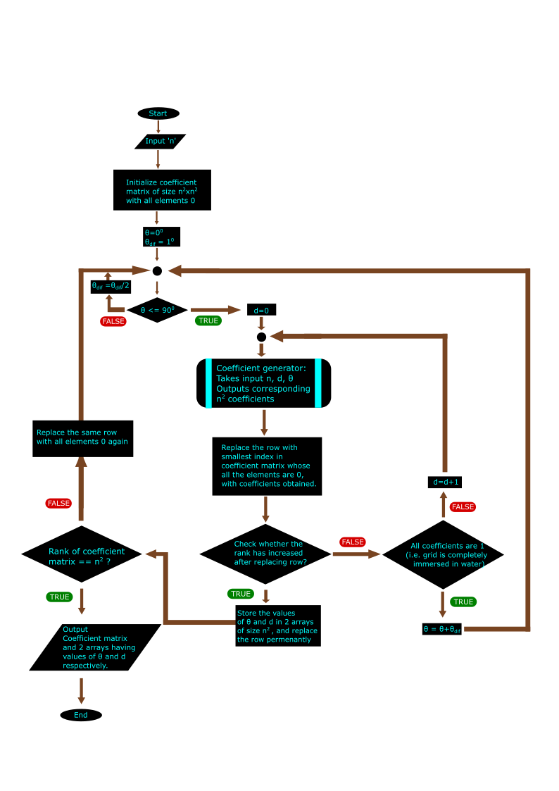

For 0 <= i,j <=n :

x_matrix and y_matrix are 2D arrays of (n+1)x(n+1) such that,

x_matrix[i][j] = x coordinate of point(i,j) after rotating it by θ in clockwise direction about origin.

y_matrix[i][j] = x coordinate of point(i,j) after rotating it by θ in clockwise direction about origin.

